The Committee

Nick Bua, Chairman
Ira Novoselsky, Treasurer
Annette Bornstein
Nick Catinazzo
Ann Fedele *
Lona Frongillo, Bocce Chair
Nick Giacobbe
Jeff Pearlman
Len Piazza
Bill Reedy
Bob Upton

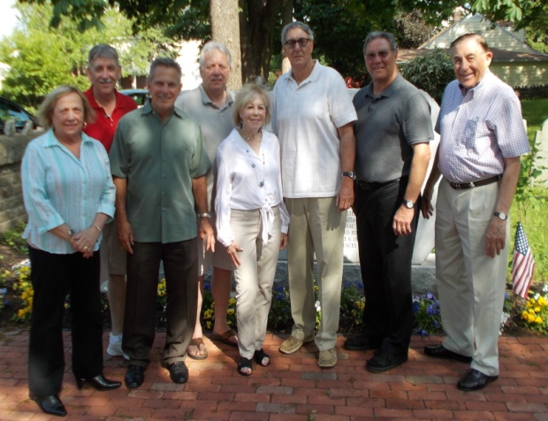

Tournament Rules

Four players per team with two teammates stationed at each end of the court rolling two balls each.

We will use United States Bocce Federation Open Rules. Tourney Director Mario Pagnoni is USBF Eastern United States Sector Vice-President.

Games to 12 points or 30 minutes, whichever comes first.

Courts are 12’ by 60’ - templates set up on the beach.

Winner of coin toss rolls object ball first, and selects color of bocce balls for his/her team.

First roll of object ball must reach at least half court and may not exit the template.

Bocce balls that leave the boundaries of the template are “dead” and may not score a point. They are removed from play for the remainder of the frame.

There is one foul line ten feet from each end. This line is used for pointing and hitting.

Players may request a measurement at any time.

This event is not a major cash prize tournament drawing top players from around the country. We want to enjoy a day of bocce with good friends while supporting a great cause. Please come with the attitude of having fun and doing your part to help an important part of our area’s history.

BOCCE ON THE BEACH
AT LOW TIDE
2014 Bocce Tournament
FUNDS TO BENEFIT
RESTORATION OF THE
RUMNEY MARSH
BURYING GROUND
(a designated
National Historic Site)

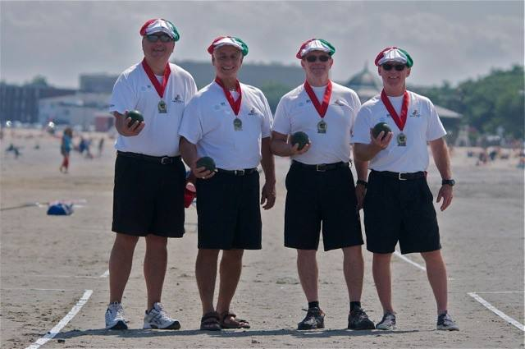
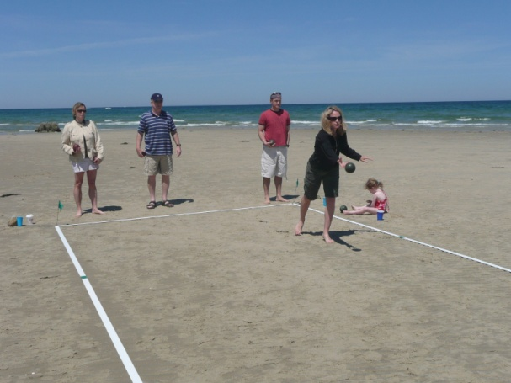
DATE: Saturday, August 16, 2014
RAIN DATE: Sunday, August 17, 2014

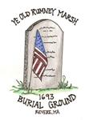
REGISTRATION:
8:15 am - 9:15 am

START TIME: 9:30 am

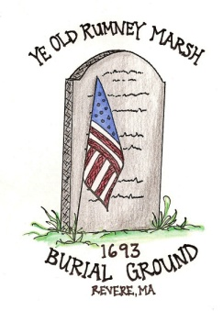
LOCATION:
Revere Beach across the street from the
State Police Barracks

AMERICA’S FIRST PUBLIC BEACH
Ye Ole Rumney Marsh
Burial Grounds
It has been referred to as the "crown jewel in Revere's history" and also "the best kept secret in Revere". We are describing the Rumney Marsh Burial Ground located on Butler Street. Historians, both local and national, have regarded this site with awe for decades. Here are interred not only soldiers and sailors from many of our wars, but everyday citizens from our community as well. Beginning with the burial of Mary Smith in the 17th century, the cemetery has been the final resting place for people from Deane Winthrop to a recipient of the Congressional Medal of Honor.
We the members of the Committee, to Restore the Rumney Marsh Burial Rounds, sincerely hope you can help us in maintaining this hallowed ground by attending our bocce tournament on Revere Beach. This exciting event will take place on Saturday, August 16th between the hours of 9:00 AM and 2:00 PM across the street from the state police Barracks. Come and witness this skilled competition unique to the sands of America's oldest public beach.
Over the years we have had successful fundraisers including a delicious lobster fest, St. Patrick’s Day Dinner Dance, sale of pins and DVD’s. Money raised has gone to erect a new monument, road signs, repair of the entry gate, repair of walls, re-setting of the brick path, renovating the cannonball rack, trail markers for the interred slaves, a bench in memory of Peter McCauley and improvement of the landscaping. Future work includes repair of grave stones, more repairs to the historic wall, tree thinning and continued beautification and maintenance of the grounds.
The Committee has been meeting monthly and we have created a DVD about the history and beauty of this cemetery which is listed on the National Register of Historic Sites (2004).

With Appreciation,
The Rumney Marsh Burial Ground
Restoration Committee

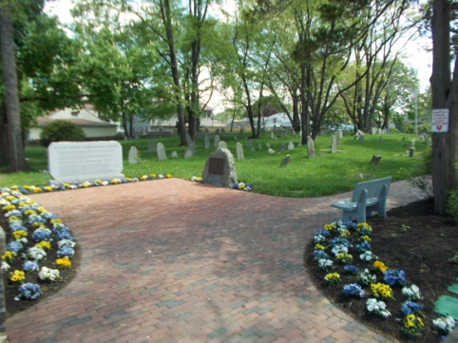

Preserve our History
Protect our Heroes

Registration Fee
$50 per person/$200 per team
Sign up by August 4, 2014

Includes Competition, Awards and
Lunch under the Tent
Teams are encouraged to wear matching attire for identification purposes
Team Name _____________________
Player #1
Player #2
Player #3
Player #4
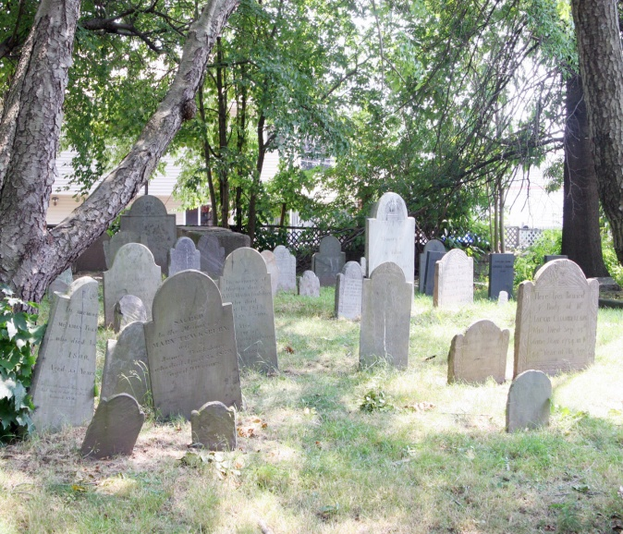
Team Contact or Sponsor

Name: ______________________________________

Phone: ______________________________

E-mail ______________________________________

Make check payable to: RMBGRC
Mail to: Veterans Service Office
249 Broadway Rear
Revere MA 02151
(Entry payments MUST be made by
August 9, 2014)

Contact Info:
www.rmbgrc.org or
781-286-8119

